Cloud-Based Ethical Hacking Simulator
Cloud Computing CS489

Student Name | Student ID
Mohamed Wael Abdelmenem | 235297
Nader Ahmad Abdelsatar | 231981
Mohab Wagdy Nasr | 232187
Ahmed Esam Abdelmonem | 233533
Omar Mohamed Waheed | 238207

Instructor Name: Prof. Rabab Mohamed Nabawy
Submission Date: 12/20/2025

Abstract
This project presents the design and implementation of a CyberRange simulation infrastructure that integrates a Machine Learning–based Intrusion Detection System (IDS) with cloud-native technologies. The system employs an XGBoost-based multi-class IDS trained using Federated Learning (FL) to preserve data privacy while maintaining high detection accuracy. Docker is used for containerization and Kubernetes for orchestration, health management, and autoscaling. Experimental results demonstrate high classification accuracy (98.47%) and effective horizontal scaling during simulated high-volume cyber-attacks.

Introduction

Project Overview
A CyberRange is a controlled environment designed to simulate real-world cyber-attacks for training, testing, and research purposes. This project implements a scalable CyberRange simulation infrastructure capable of detecting and classifying network attacks in real time using Machine Learning.

Purpose and Objectives
The objectives of this project are to:
- Design a realistic cyber-attack simulation environment.
- Implement an intelligent IDS capable of multi-class attack classification.
- Preserve data privacy using Federated Learning.
- Ensure scalability and resilience using Docker and Kubernetes.

Problem Statement
Traditional Intrusion Detection Systems are often centralized, static, and difficult to scale. Additionally, centralized ML training raises privacy concerns. This project addresses the need for a distributed, scalable, and privacy-preserving IDS suitable for modern CyberRange environments.

Background and Literature Review
Machine Learning-based Intrusion Detection Systems have gained significant attention due to their ability to detect complex and previously unseen attack patterns. Benchmark datasets such as CIC-IDS2017 and CSE-CIC-IDS2018 have become standard for evaluating IDS performance due to their realistic traffic and comprehensive attack coverage (Sharafaldin et al., 2018).

Machine Learning for IDS
Ensemble learning methods, particularly gradient boosting techniques, have demonstrated superior performance on structured network flow data. Studies comparing ML classifiers on CSE-CIC-IDS2018 report that XGBoost outperforms Random Forests, SVMs, and KNN in terms of accuracy and detection stability (Al-Hawawreh et al., 2023). Surveys of ML-based IDS approaches further highlight XGBoost as a state-of-the-art model for multi-class intrusion detection due to its robustness and efficient inference (Ferrag et al., 2020).

Federated Learning for Intrusion Detection
Federated Learning enables collaborative model training without sharing raw data, making it suitable for privacy-sensitive environments. Nguyen et al. (2022) demonstrated that FL-based IDS systems can achieve comparable performance to centralized models while maintaining data confidentiality. Similarly, Fed-ANIDS applies FL with anomaly detection models and shows strong results on CIC-based datasets, even under non-IID data distributions (Li et al., 2023).

Research Gap
Although prior research demonstrates the effectiveness of ML and FL for IDS, limited work integrates these techniques into a fully containerized and autoscaling CyberRange infrastructure. This project bridges that gap by combining FL-trained IDS models with Kubernetes-based deployment and scaling.

Problem Statement
The key challenge addressed in this project is the development of an IDS that is accurate, privacy-preserving, and scalable under high traffic loads. The system must detect multiple attack categories while dynamically adapting to resource demands during large-scale cyber-attack simulations.

System Requirements / Tools Used

Software Requirements
- Operating System: Linux-based environment
- Containerization: Docker
- Orchestration: Kubernetes
- Machine Learning: XGBoost, Scikit-learn
- Federated Learning: Flower (flwr)
- API Framework: Flask, Gunicorn

Programming Languages
- Python 3.10
- YAML (Kubernetes manifests)

Hardware Requirements
- Cloud or on-premise infrastructure capable of running Kubernetes
- Multi-core CPU resources for parallel inference

System Integration & Architecture
The CyberRange platform employs a loosely coupled architecture to orchestrate simulations, stream telemetry, and enforce security policies.

Integration Flow
- The Frontend dashboard initiates an attack simulation via a REST request to the API Gateway.
- The API Gateway forwards the request to the Scenario Microservice.
- The Scenario Microservice orchestrates attacker and IDS deployments using the Kubernetes API.
- The Backend establishes WebSocket connections (Socket.io) to stream real-time logs from attacker containers.
- The HPA Controller dynamically scales attacker and IDS pods based on CPU utilization.

Network and Component Architecture (Visualization)
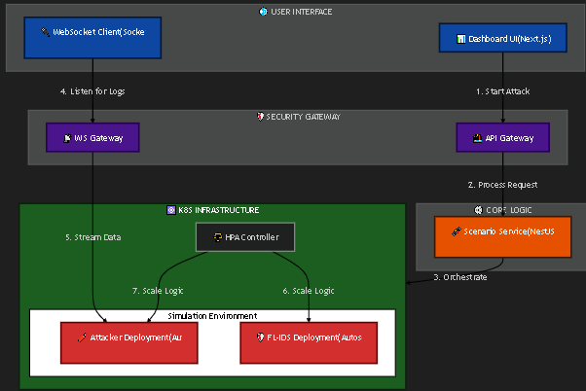
illustrates the network and component architecture with autoscaling enabled.
- User Interface Layer:
  - Dashboard UI (Next.js)
  - WebSocket Client (Socket.io) for live telemetry
- Security Gateway Layer:
  - API Gateway for REST-based control operations
  - WebSocket Gateway for log streaming
- Core Logic Layer:
  - Scenario Service (NestJS) responsible for orchestration and policy enforcement
- Kubernetes Infrastructure:
  - Attacker Deployments (Bot, DDoS, Infiltration)
  - FL-IDS Deployment
  - HPA Controller for dynamic scaling
The architecture enables real-time observability, controlled simulation execution, and elastic scaling during high-intensity cyber-attack scenarios.

Methodology / Approach

Architecture Overview
The overall system architecture combines federated machine learning, containerized microservices, and Kubernetes-based orchestration. This approach ensures scalability, privacy preservation, and resilience under high-load attack simulations.

Steps Followed
- Dataset preparation and preprocessing
- Federated training of the IDS model
- Model evaluation and export
- Docker containerization of the IDS service
- Kubernetes deployment and autoscaling configuration

Algorithms and Models
- Problem Type: Multi-class classification
- Model: XGBoost Classifier
- Training Strategy: Federated Learning with 5 clients over 10 rounds

Data Collection and Preprocessing
- Datasets: CIC-IDS2017, CSE-CIC-IDS2018
- Features: 79 network flow features
- Preprocessing Techniques:
  - SMOTE oversampling for class imbalance
  - Feature selection aligned with model schema
  - Handling missing and infinite values

System Design
This section presents the visual representation of the CyberRange system, focusing on component interactions, deployment topology, and data flow during simulation execution.

Network and Component Architecture (Visualization)
Illustrates the network and component architecture of the CyberRange platform, corresponding to the integration described in Section 5.2.
Architecture Description:
- The Frontend (Next.js) acts as the user interaction layer, providing dashboards, simulation consoles, and traffic visualization interfaces.
- The Backend (NestJS) serves as both an API Gateway and WebSocket Gateway:
  - REST APIs are used to issue start and stop simulation commands.
  - Socket.io is used to establish persistent WebSocket connections for real-time telemetry.
- The Scenario Microservice contains the SimulationService, which communicates directly with the Kubernetes API to deploy scenario-specific resources using YAML manifests.
- Within the Kubernetes Cluster, multiple components are deployed:
  - Attacker Containers responsible for generating malicious traffic.
  - The FL-IDS Pod that performs real-time intrusion detection.
  - The HPA Controller, which monitors CPU utilization and automatically scales IDS pods.
- Log streams from attacker containers are accessed via the Kubernetes API and forwarded by the backend to the frontend over WebSocket connections.
Communication Paths:
- Frontend → Backend: REST (start/stop simulation), WebSocket (telemetry)
- Backend → Kubernetes API: Deployment, scaling, and log streaming
- Kubernetes → Backend → Frontend: Real-time logs and status updates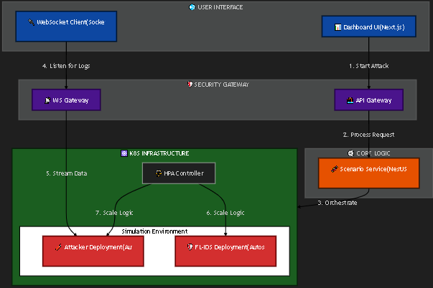
This architecture enables loose coupling between components, real-time observability, and dynamic scalability during cyber-attack simulations.

Flowchart
The operational flow of a simulation is as follows:
- User initiates a scenario from the frontend dashboard.
- Backend validates user permissions and questionnaire score.
- Scenario Microservice deploys attacker and IDS containers.
- IDS analyzes traffic and generates predictions.
- Logs and metrics are streamed to the frontend in real time.
- Simulation is terminated and resources are cleaned up.

Implementation

Machine Learning IDS Implementation
The CyberRange simulation integrates an Intelligent Intrusion Detection System (IDS) based on a Machine Learning model designed for multi-class network traffic classification. The IDS distinguishes between benign traffic and 14 malicious attack categories, including DDoS, Bot, Brute Force, and Infiltration.
- Problem Type: Multi-class classification
- Model: XGBoost Classifier, selected for its high performance on structured network flow data and low inference latency
- Training Strategy: Federated Learning (FL) using the Flower framework, trained across 5 distributed clients for 10 rounds to enhance robustness and preserve data privacy

Dataset and Preprocessing
- Datasets: CIC-IDS2017 and CSE-CIC-IDS2018
- Features: 79 flow-based features, with key predictors including Dst_Port, Protocol, and Flow_Duration
- Classes:
  - Benign: Normal network traffic
  - Malicious: 14 attack categories (e.g., DDoS, Bot, Infiltration)
The trained model achieved an overall accuracy of 98.47%, with several attack classes reaching 100% precision and recall.
The finalized model was trained using an offline pipeline and exported as federated_ids_model.json for portability and version compatibility.

Model Serving
The IDS model is served using a Flask-based REST API implemented in ids_server.py. The service exposes:
- POST /predict: Accepts network flow features and returns the predicted class with confidence scores
- GET /healthz: Provides health and readiness status for orchestration and monitoring

Docker Containerization
Both the IDS service and attack simulation services are fully containerized to ensure consistency and scalability.
Dockerfile Design:
- Base Image: Python 3.10-slim / 3.11-slim
- Optimizations: Minimal layers, installation of only required dependencies (e.g., requests, xgboost)
Health Checks:
- ids_server.py: Exposes /healthz on port 5000 for Kubernetes probes
- attacker.py: Runs a lightweight http.server on port 8000 to support liveness and readiness probes

Kubernetes Deployment (Scalable Architecture)
The system architecture was refactored from static Kubernetes Jobs to dynamic Deployments to support autoscaling and long-running simulations.
Deployment Resources:
- IDS Deployment: fl-ids-deployment (Replicas: 1–5)
- Attacker Deployments:
  - bot-attacker (Replicas: 1–10)
  - ddos-attacker (Replicas: 1–20)
  - infiltration-attacker (Replicas: 1–5)
A LoadBalancer service exposes the IDS API on port 5000.

Health Checks and Probes
All Kubernetes Deployments implement both liveness and readiness probes:
- Liveness Probe: Automatically restarts containers if the application becomes unresponsive
- Readiness Probe: Ensures traffic is routed only when services are fully initialized

Autoscaling (Horizontal Pod Autoscaler)
Horizontal Pod Autoscaling (HPA) dynamically adjusts system resources based on runtime load.
HPA Configuration:
- Metric: CPU utilization
- Target Range: 50–70%
Autoscaling Behavior:
- Attackers: Scale out under increased simulation load, emulating distributed attacks
- IDS: Scales out as traffic volume increases to maintain low-latency detection

Results & Testing

Performance Results
- Overall Accuracy: 98.47%
- DDoS (HOIC): 100% Precision / 100% Recall
- Bot: 100% / 100%
- Brute Force (SSH): 100% / 100%
- Benign: 99% Precision / 100% Recall

Scalability Testing
During simulated DDoS attacks, CPU utilization increased and triggered HPA scaling from 1 to 3 replicas within 60 seconds, maintaining low inference latency.

Discussion
The system successfully demonstrates the feasibility of combining Federated Learning with cloud-native deployment for IDS applications. High accuracy and effective autoscaling validate the architectural choices.

Conclusion
This project delivers a scalable, privacy-preserving CyberRange simulation infrastructure. By integrating Federated Learning, Docker, and Kubernetes, the system achieves accurate intrusion detection while adapting dynamically to attack intensity. The project highlights best practices for modern cybersecurity system design.

References
Sharafaldin, I., Lashkari, A. H., & Ghorbani, A. A. (2018). Toward generating a new intrusion detection dataset and intrusion traffic characterization. ICISSP.
Ferrag, M. A., et al. (2020). Deep learning approaches for intrusion detection systems: A survey. IEEE Communications Surveys & Tutorials.
Al-Hawawreh, M., et al. (2023). Performance evaluation of machine learning algorithms for intrusion detection using CSE-CIC-IDS2018. Journal of Information Security and Applications.
Nguyen, D. C., et al. (2022). Federated learning for intrusion detection in IoT networks. Future Generation Computer Systems.
Li, T., et al. (2023). Fed-ANIDS: Federated anomaly-based intrusion detection system. Expert Systems with Applications.

